Welcome to the ad-free internet

As the rich pay to banish commercials, advertisers hunt for their attention elsewhere

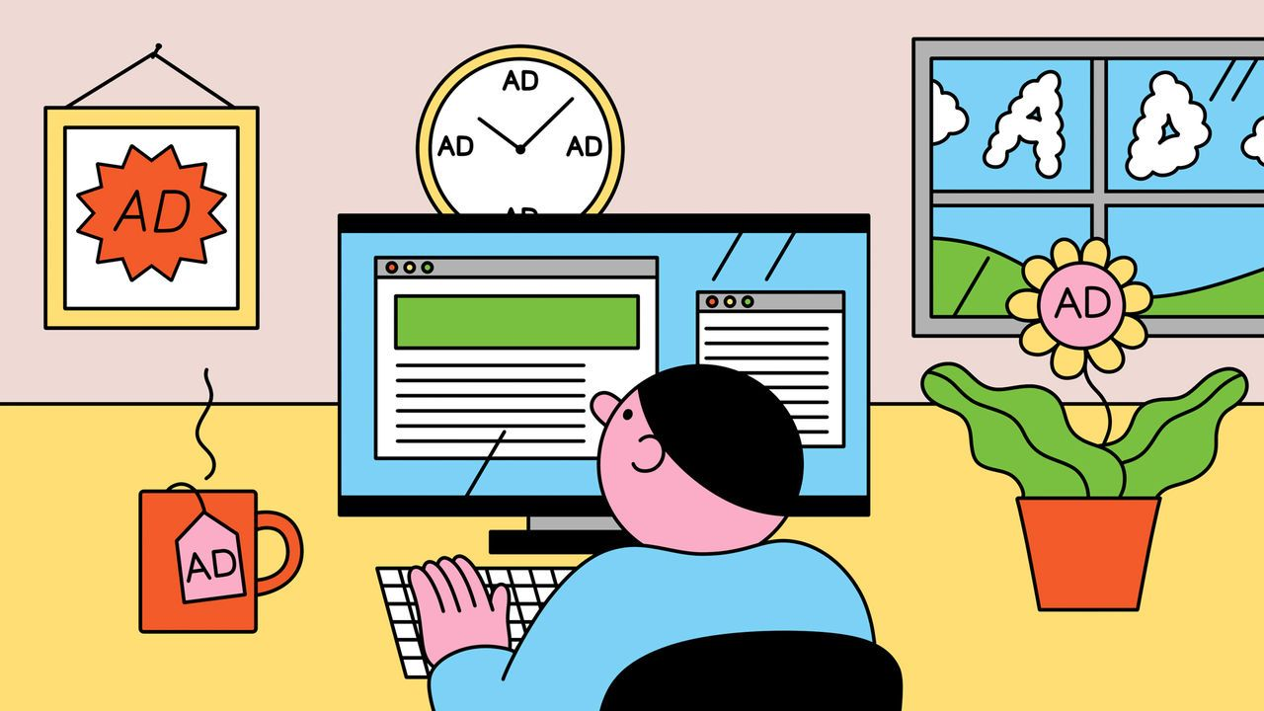

Dec 11th 2023

For a preview of what lies wrapped beneath the Christmas tree, log in to Facebook. The social network tracks its users’ behaviour so intimately that it is able to [personalise ads](https://www.economist.com/business/2019/04/04/facebooks-ad-system-seems-to-discriminate-by-race-and-gender) with a precision that sometimes verges on mind-reading. Its ad-stuffed newsfeed at this time of year embodies the internet’s great trade-off: consumers enjoy free services, but must submit to bombardment with commercials from companies that know who has been naughty or nice.

Yet increasingly, those with deep enough pockets are getting the chance to escape the online admen. Last month Facebook’s owner, Meta, began offering customers in Europe [ad-free subscriptions](https://www.economist.com/business/2023/02/22/facebook-sells-subscriptions-as-the-ad-business-stumbles) to Facebook and its sister network, Instagram, for €9.99 ($10.85) a month. In October X (formerly Twitter) launched an ad-free option. In the same month TikTok, a fast-growing Chinese-owned video app, announced that it was testing an ad-free subscription. The following month Snapchat, another social-media rival, said it was doing the same.

Social networks are not the only medium allowing the group that advertisers most covet—the better-off with money to splurge—to wriggle beyond their reach. From video and audio to news and gaming, a combination of regulation and technological change is encouraging media companies to offer alternatives. “We are in a world where it will be increasingly possible to avoid ads,” says Brian Wieser of Madison and Wall, an advertising consultancy. As the rich opt out of commercials on some platforms, advertisers are therefore looking for new places to catch them.

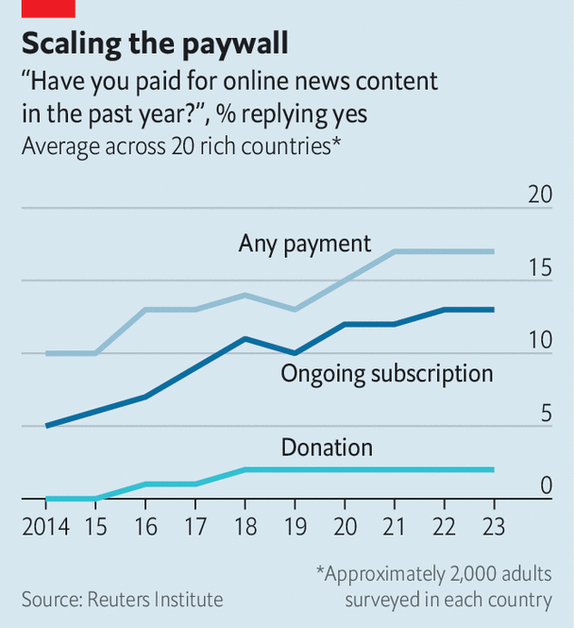image: the economist

Grabbing the attention of well-heeled consumers via old media has been getting harder for some time. As the internet has eroded the value of their ads, newspapers and magazines have made a decade-long pivot to other sources of revenue. Whereas in 2014 only 5% of adults in rich countries paid for a subscription to an online news site, this year 13% did, according to Oxford University’s Reuters Institute. During the same period ad-supported radio has been giving way to streamed music and podcasts on platforms like Spotify, 40% of whose 575m users cough up $10.99 a month to listen ad-free.

## And now, for a break from commercials

Television, on which ads are worth $160bn a year, is well into its own digital transition. Last year streaming overtook cable and broadcast to become the most-watched tv in America, according to Nielsen, a firm which tracks viewership. Whereas linear tv is stuffed with ads, three-quarters of American streaming customers pay to skip ads, estimates Antenna, another data firm. Streamers such as Netflix and Disney+ have launched ad-supported tiers in the past year or so; Amazon’s Prime Video will follow suit shortly. But they show only about four minutes of commercials per hour, compared with more like 15 on American broadcast tv. As viewers drift to streaming, television’s ad inventory in America will fall by a quarter in the next four years, estimates Mr Wieser.

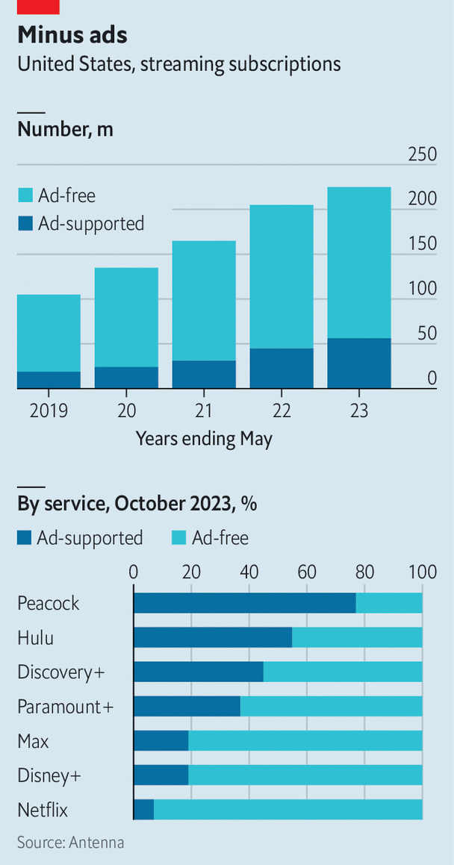image: the economist

Social media seemed like a safer space for ads. For years Facebook promised it was “free and always will be”. Two things have changed that. One is regulation. Meta’s ad-free plan in Europe follows a series of court rulings establishing that, under regional data-protection rules, tech firms must get users’ consent before showing them personalised ads. Rather than making its ads less effective, Meta is offering the alternative of no ads, for a price. (Privacy campaigners say that the price is so high as to be prohibitive; expect more legal battles in the new year.) Meta will not launch the plan elsewhere unless it has to: “We will always advocate for an internet funded by ads,” it said on December 4th. But other countries may get ideas. Britain and India are sharpening their digital-privacy laws. Tech firms are also watching Brazil, Indonesia and Australia (where Snapchat is testing its ad-free option).

The other change comes from the tech platforms. Since 2021 Apple has let customers opt out of being tracked by apps, crippling the ability to personalise ads and triggering a rush to alternative methods of monetisation. Snapchat launched a $3.99-per-month subscription last year offering extra features; this September it had 5m subscribers. Mobile games, which often rely on ads, have moved towards alternatives such as in-app purchases and subscriptions, says Tianyi Gu of Newzoo, a firm of analysts. Apple and Netflix are among those to have launched ad-free game subscriptions.

The existence of ad-free options does not guarantee take-up. Few Europeans will pay for Facebook or Instagram, believes Eric Seufert, author of the “Mobile Dev Memo” newsletter. “Meta will use the low adoption rate to champion the ad-supported business model as a consumer preference,” he predicts. However, as Meta’s networks deal increasingly in video, switching off their ads may become more tempting. YouTube Premium, which charges $13.99 per month to go ad-free, had 80m subscribers last year (the latest figure available), behind only Netflix, Disney+ and Amazon Prime among Western platforms.

Children in particular are increasingly off-limits to ads by default. Snapchat said in August that most of its ad-targeting tools would no longer be available to use on under-18s in the eu and Britain, to comply with new privacy rules. Meta has made Facebook and Instagram entirely ad-free for European youngsters while it works out its legal position.

Whoever pays to opt out of ads tends for now to be wealthier than those who sit through them. Among those paying for news online, eight out of ten are from medium- or high-income households, according to the Reuters Institute. As well as having more money, the wealthy tend to be more privacy-conscious: the richest users are likeliest to decline to be tracked on their iPhones, says Mr Seufert.

Still, early indications are that, in tv at least, the difference may not be big. In America the highest-earning households make up 9% of ad-supported subscribers and 11% of ad-free ones, finds Antenna. Mr Wieser suggests that, as consumers are squeezed and spend less on nights out, they may in fact be more inclined to pay for ad-free tv.

Either way, admen are confident that they have other ways to reach valuable consumers. Worldwide ad spending (excluding American political spots) will reach $889bn in 2023 and grow by 5-6% annually for the next five years, led by digital ads, forecasts Groupm, which places ads on behalf of brands. The number of ads seen on television may fall, but streamers’ ability to target the commercials will make them much more effective than conventional tv spots, argues Mark Read, head of wpp, the world’s largest ad company and Groupm’s parent firm. Streamers’ shorter ad breaks will be better at holding viewers’ attention. “Our clients understand that a two- to three-minute ad load is more valuable than a nine-minute ad load,” says Mr Read. In addition, streamers are eating into the time spent watching ad-free public-service broadcasters such as Britain’s bbc.

Advertisers can also fall back on platforms from which the rich have no escape. Spending on out-of-home media—billboards and the like—has grown by 7% this year, and is now above its pre-pandemic level, according to Magna, a research arm of Interpublic, another big ad agency. Sponsorship of sports events and the like remains immune to digital disruption. And other kinds of corporate persuasion, such as public relations, may benefit as it gets harder to reach people via old-school ads, says Mr Wieser.

Perhaps the biggest new advertising opportunity is in areas that never previously showed ads at all. Amazon’s ruse of selling ads alongside search results on its retail site—something it began doing little more than a decade ago—will earn around $45bn this year, more than the entire global newspaper industry did. Last year Uber started selling ads in its ride-hailing and delivery apps, personalising them using its own data on its customers (something Apple’s anti-tracking changes do not affect). It expects to make $1bn next year from this new sideline. Marriott hotels launched an ad network last year to send targeted messages to guests on their in-room tvs. United Airlines is said to be planning to show personalised ads to passengers during their in-flight entertainment. Groupm predicts that this kind of “retail media” will be worth more than tv advertising by 2028.

Even on social networks there will be ways for brands to reach people who pay to go ad-free. Advertisers increasingly rope in charismatic “influencers”, who promote products to users who follow them and share their content by choice. wpp recently took a group of them to Lapland to visit Santa’s home, as part of a promotion for Coca-Cola. Users who pay to block ads in some areas are still likely to find them popping up in new ones. ■